Exp. No: 4
Analysis of Continuous Charge Distribution in Electric Field (Line, Surface and Volume Charge Density)
Test case (i) Determination of line, surface and volume charge density for given charge, length and radius
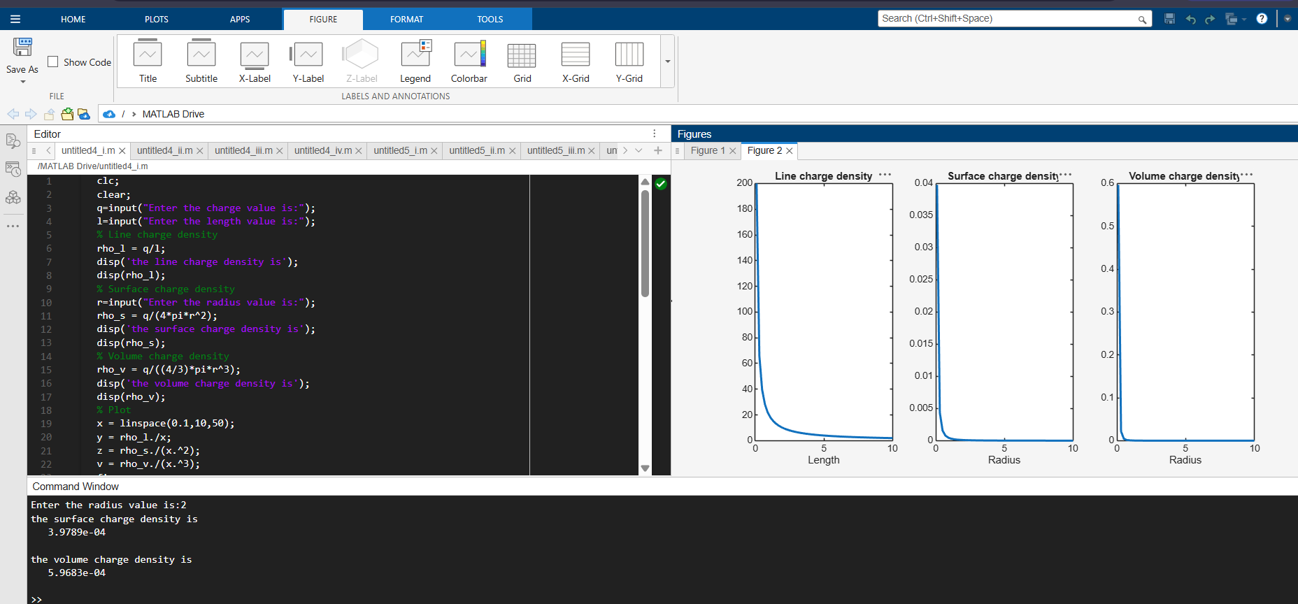
Test case (ii) A long wire of length L = 10 m carries a uniform charge of Q = 50 μC. Calculate the line charge density and plot electric field variation
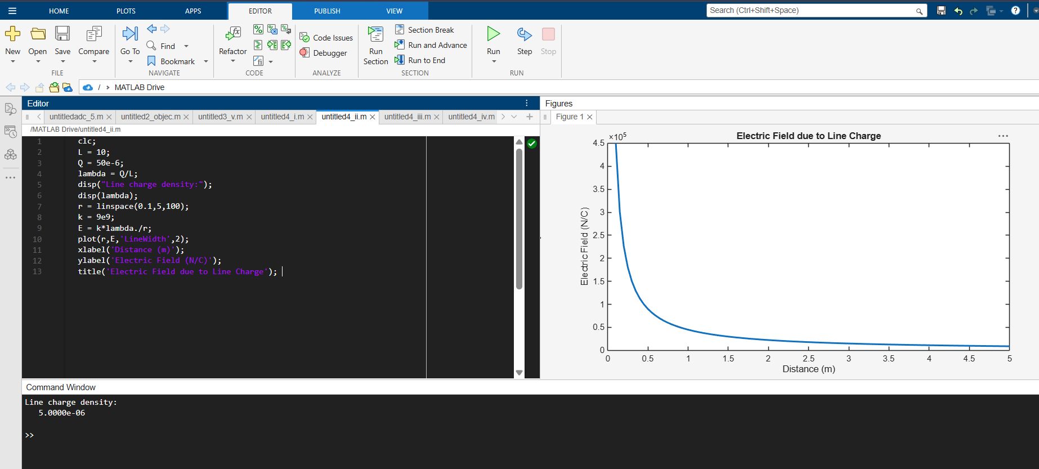
Test case (iii) A uniformly charged disk of radius R = 0.5 m with total charge Q = 10 μC. Calculate surface charge density and electric field
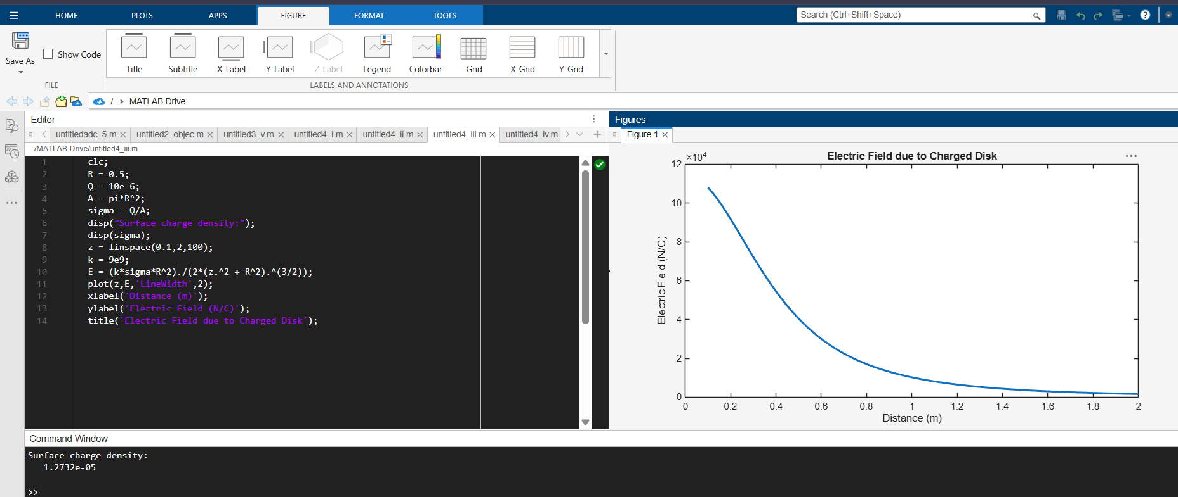
Test case (iv) A uniformly charged sphere of radius R = 2 m with total charge Q = 20 μC. Calculate volume charge density and electric field inside and outside 3
